Reading: If I ruled the world
Read the texts and do the exercises


Allan, 17
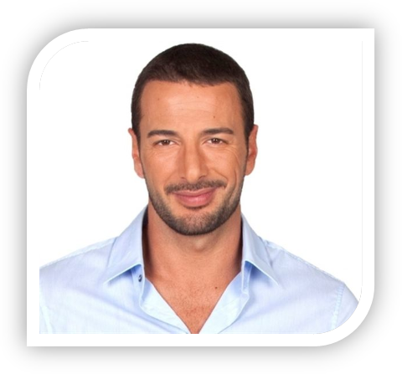
If I ruled the world, I would erase the borders! We would live in a world without countries. If we don’t have any countries, we won’t have any wars. If I had enough money, I would spend it on education and new technologies. People would live in a better world if every child could go to university and learn about other cultures and traditions. I would also finance new scientific projects like a journey to Mars! Finally, the most important thing: if I ruled the world, I would forbid Justin Bieber!

Bob, 41
I would do a lot of great things if I ruled the world! I would forbid men to cut down trees. If we don’t respect the environment, we will have a lot of problems in the future! I would also give 1000€ per month to every family in the world because poverty is the enemy number one of mankind. Finally, I would start great economic projects to help the African continent.
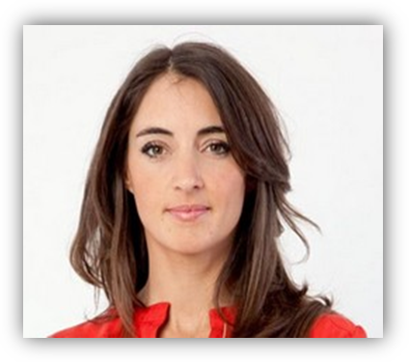
Clair, 29
If I ruled the world, I would get rid of the nuclear weapons! Those weapons are a major danger for all peoples in the world. If I could, I would also protect more animals. Some of them will disappear if we don’t do anything to help them. I would also try to find a cure for every illness!
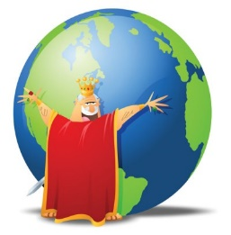
Reading: If I ruled the world
Your turn! What would you do if you could rule the world?
If I ruled the world, I would invest the money In jobs, if we have jobs, we would have more money, if we have more money, we could pay for better services, if we pay for better services, we would live more relaxed, if we live more relaxed, we would live friendlier

